**Task 3: Predict the House Numbers from Images.**

**Objective**: Use convolutional neural network on the SVHN dataset using a single digit classification.

* We have used Deep Learning to train the model with 65931 images, validated with 7326 & finally tested on 26032 images with 10 classes.

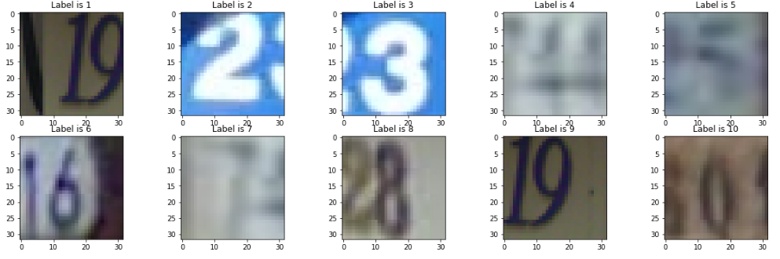

* **Base model without Batch Normalization**

**Accuracy: 87.34 %**

**Parameters:**

* + 3 hidden layers i.e. Conv2D layer with kernel size (4,4) & rectified linear activation.
  + Drop out of 0.2
  + 1 Max Pooling of (2,2)
  + 2 Dense Layer i.e. one of 123 matrix with rectified linear activation and output layer with SoftMax activation.
  + We trained the model using batch size 128 with 20 iteration.
  + Time taken for training model was 2 hours using Keras & TensorFlow with CPU.

**Model Results:**

*Image Predicted:*

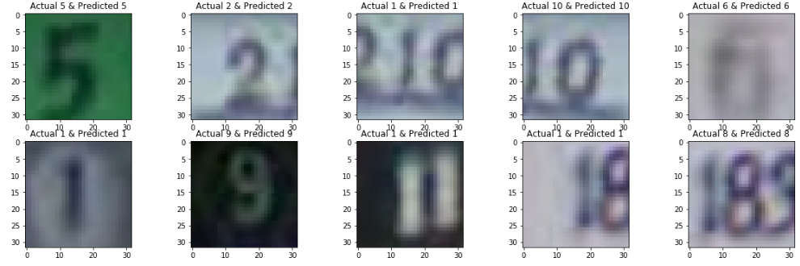

* **Final model without Batch Normalization**

**Accuracy: 89.64 %**

**Parameters:**

* + 3 hidden layers with each drop out of 0.2 & kernel of 4,4
  + & Batch normalization of 2 for 2 hidden layers. Name itself defines it meaning we have use normalization so that model learn each of itself more independently of other layers.
  + 1 Max Pooling of (2,2)
  + 3 Dense Layer i.e. two of 123 matrix with rectified linear activation and output layer with SoftMax activation.
  + We trained the model using batch size 128 with 20 iteration.
  + Time taken for training model was 5 hours using Keras & TensorFlow with CPU.

**Model Results:**

*Image Predicted:*

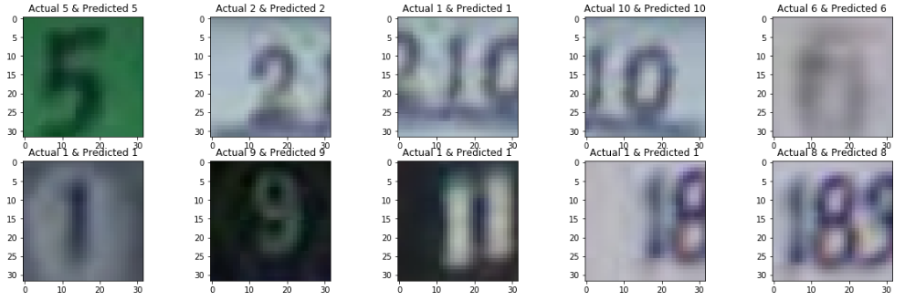

***Model Comparison using Confusion Matrix:***

Let compare two model based on confusion matrix and identify which digits were correctly classified or misclassified.

Base Model without Batch Normalization Final Model without Batch Normalization

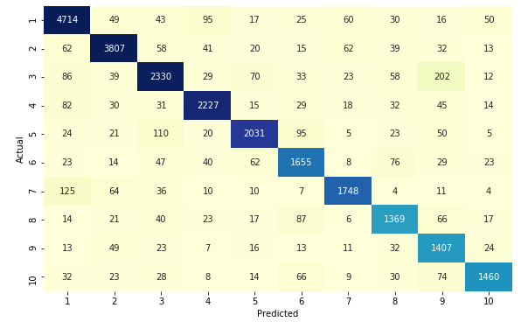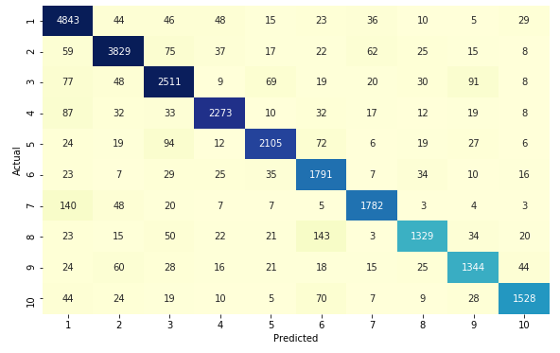

*Inferences:*

* Out of total 1 was mostly was correctly classified in Base Model but few misclassified out which highest were misclassified in 7 i.e. around 125 compared to other this happen because 1 & 7 have more similarities that why model was not able to differentiate.
* But what we see in Final Model misclassified of 1 in 7 was increased and reduced from 2 & 3.
* Similar it occurred of 3, were it was misclassified in 9 but by using batch normalization number 3 was more benefited as its misclassified number from 202 was reduced to 91 i.e. almost 55 % decrease in misclassification.
* We can see more interesting insights from base plots.

**Task 4: Predict the Dog & Cat Breed using Images.**

**Objective**: Use the weights of a pre-trained convolutional neural network included in Keras.

* We have used VGG16 model, with weights pre-trained on ImageNet.
* Used same pre-process used on this VGG16 model.
* Train pet dataset with 5511 images & finally tested on 1838 images with 37 classes.
* We have used Colab from google to train the model using Logistic Regression & SGD Classifier.

**Logistic Regression**

**Accuracy: 87.21 %**

**Model Results:**

*Image Predicted:*

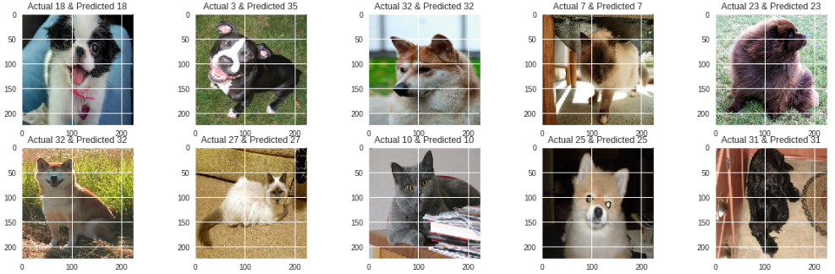

**SGD Classifier**

**Accuracy: 82.58 %**

**Model Results:**

*Image Predicted:*

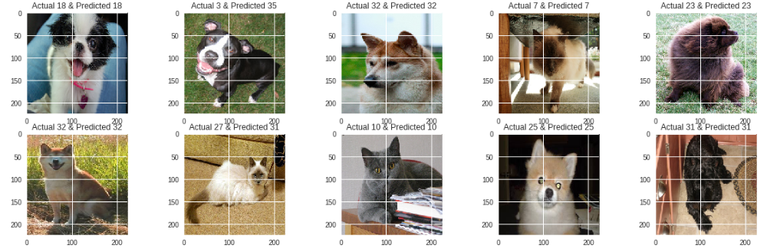

***Model Comparison using Confusion Matrix:***

Let compare two model based on confusion matrix and identify which breeds were correctly classified or misclassified.

Logistic Regression.

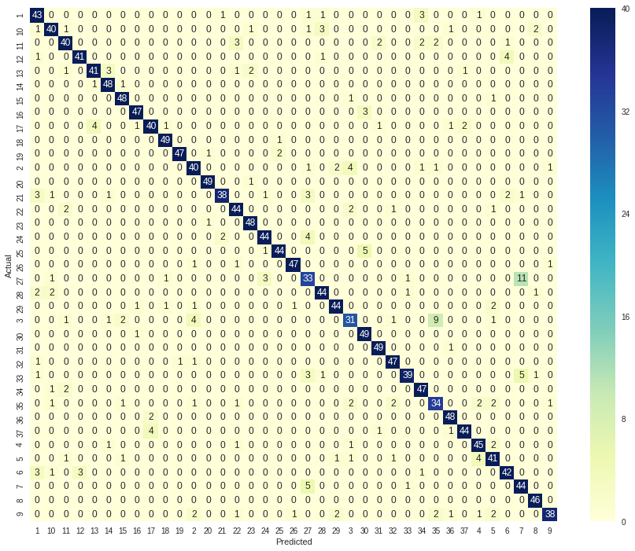

SGD Classifier

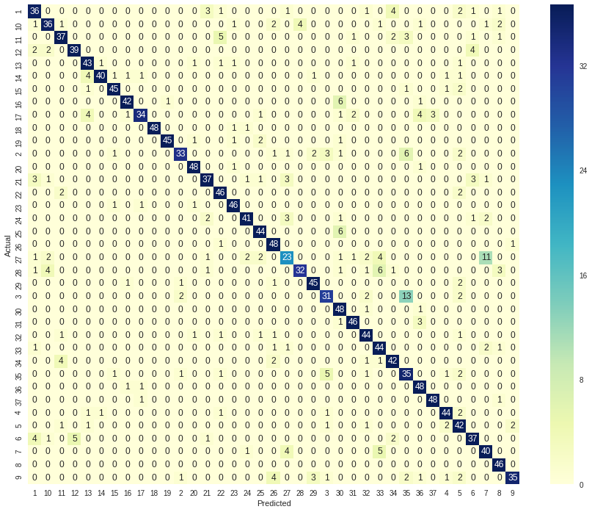

*Inferences:*

* Logistic regression performed better than SGD classifier because its only gradient.
* American pit bull terrier breed was 13 times was misclassified in SGD but it was reduced to 9 times in logistic regression as Staffordshire bull terriers because of their similarities.
* Similar it occurred of Ragdoll cat, were it was misclassified as a Birman cat best model also was not able to reduce the error mostly because of their high similarities.
* We can see more interesting insights from base plots.